# CS 255 System Design Document Template

## UML Diagrams

### UML Use Case Diagram

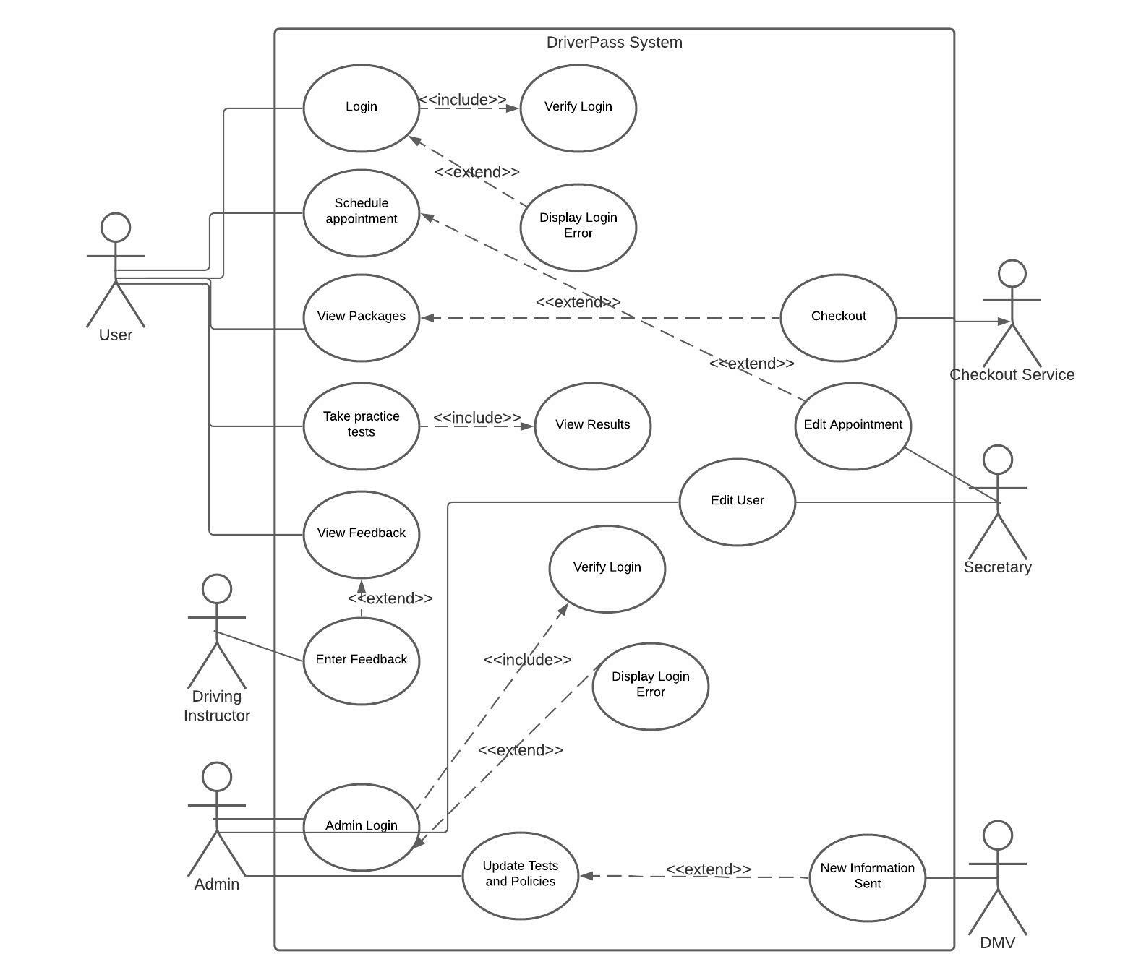

### UML Activity Diagrams

*.]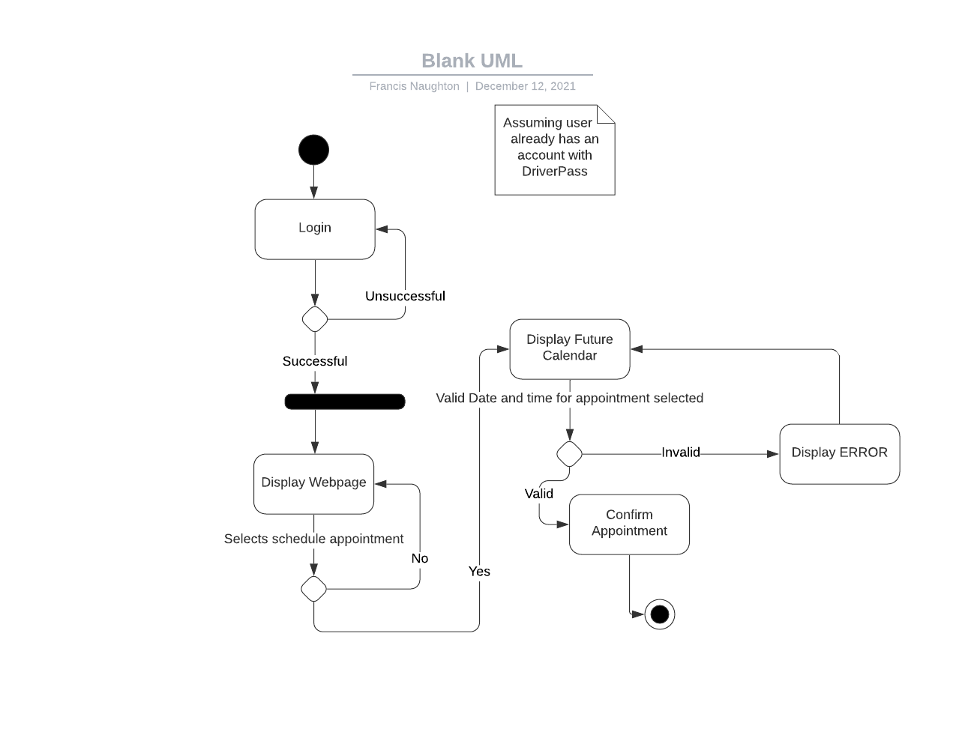*

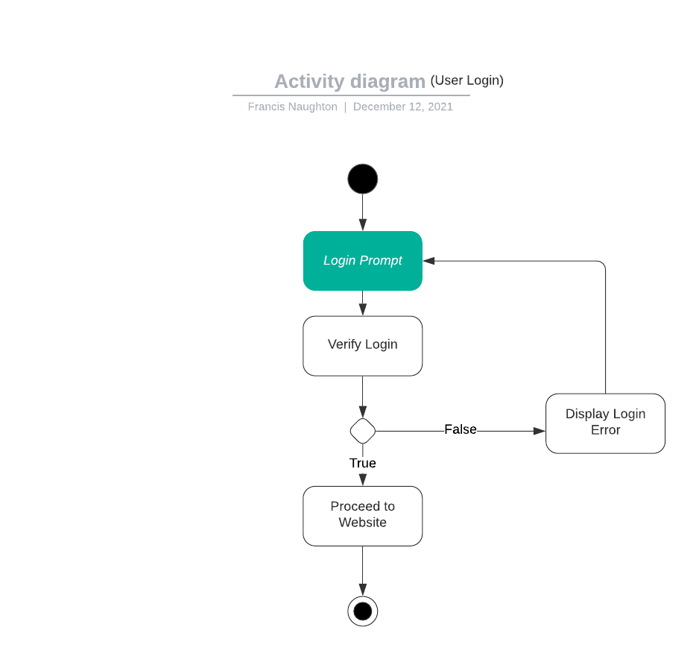

### UML Sequence Diagram

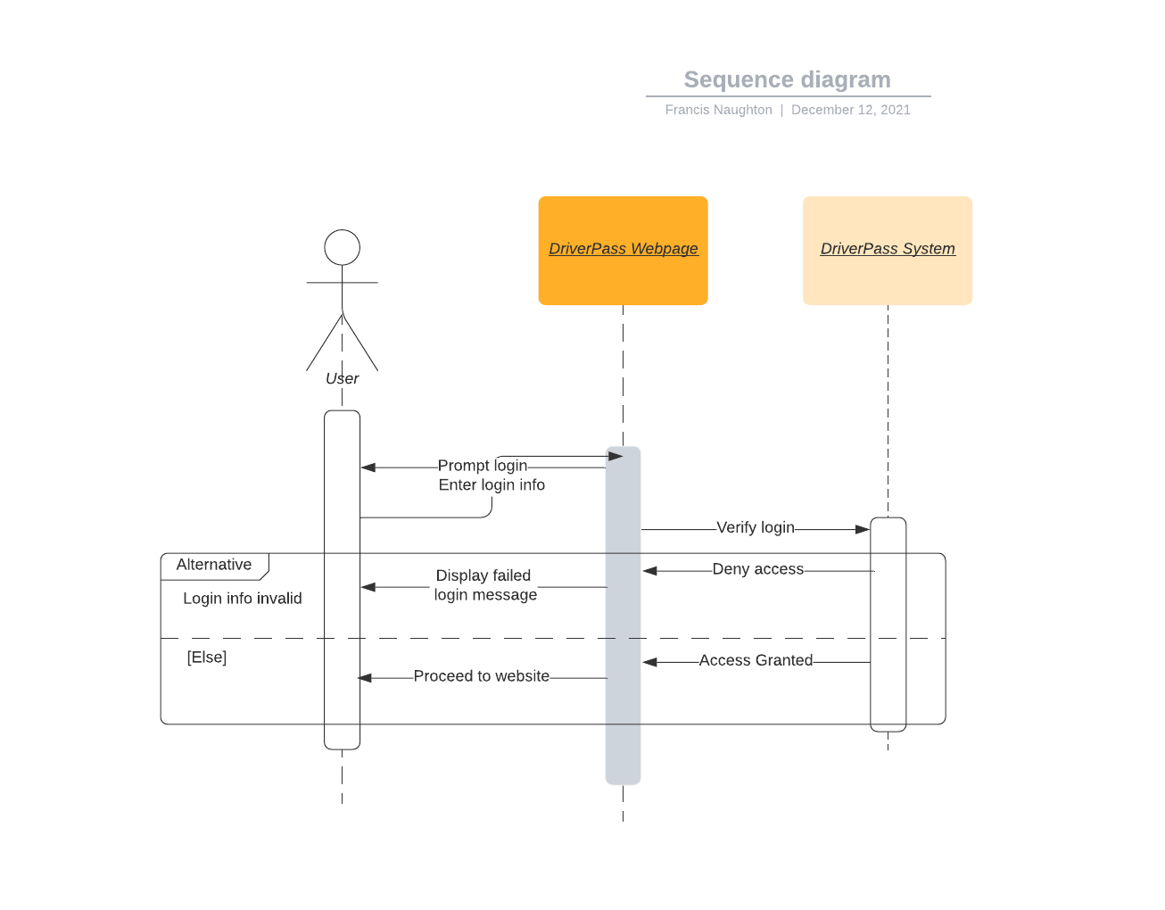

### UML Class Diagram

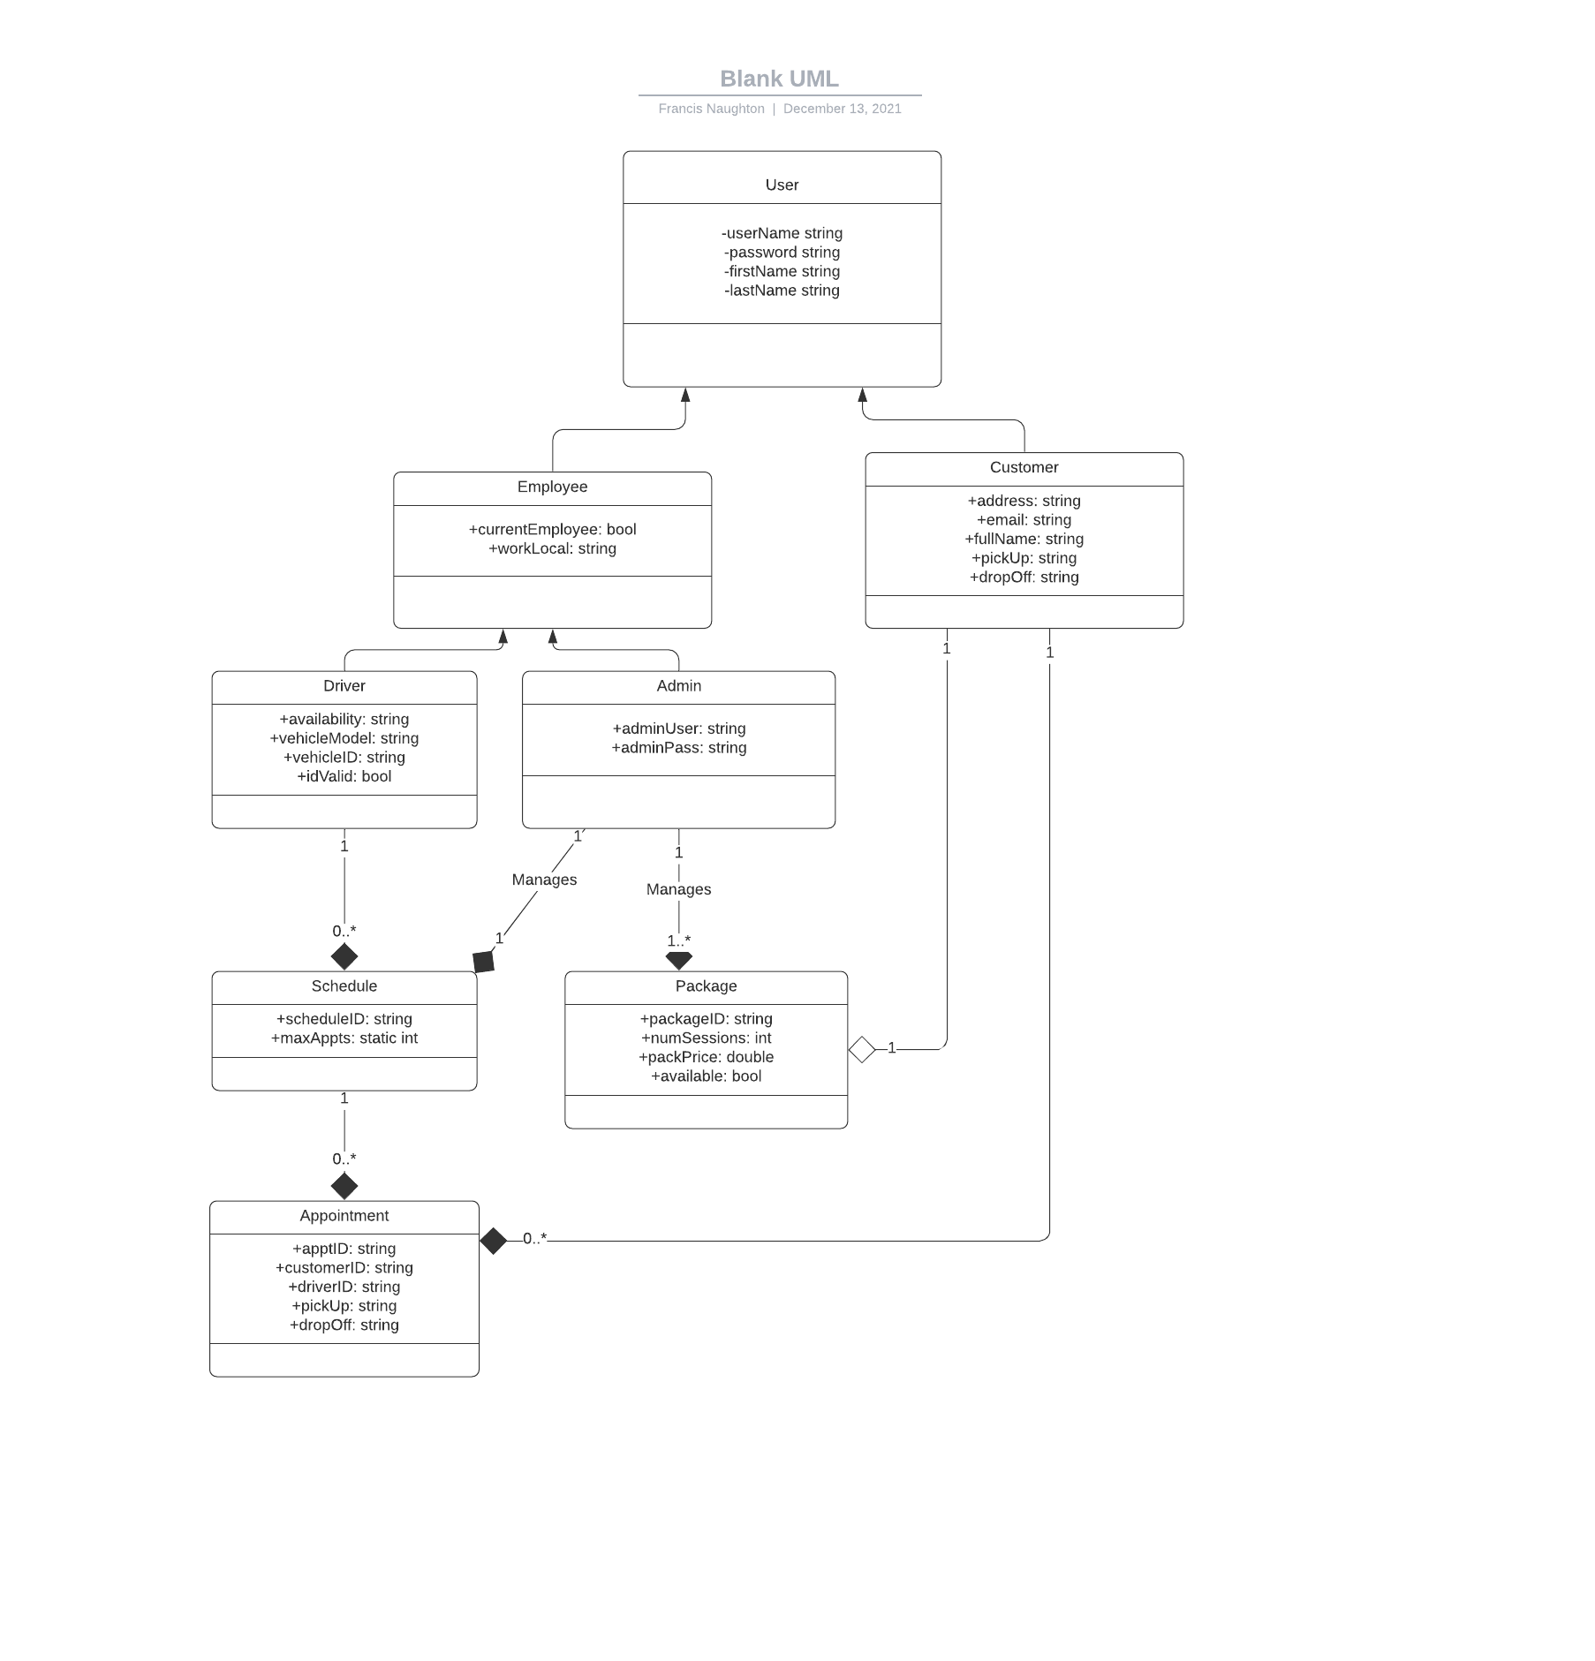

## Technical Requirements

*[Based on the diagrams you have created, describe the technical requirements of your system. These requirements should address the required hardware, software, tools, and infrastructure necessary for your system design.]*

The driver pass system is going to require a internet connection and a browser. IDE’s will be used to write the code in python. The system’s database will be cloud run and managed.